Name :- Aniruddha Mukherjee

Conizance Preliminary task-1

15/4/2022

1st  creating account, setup, and making a repository in github

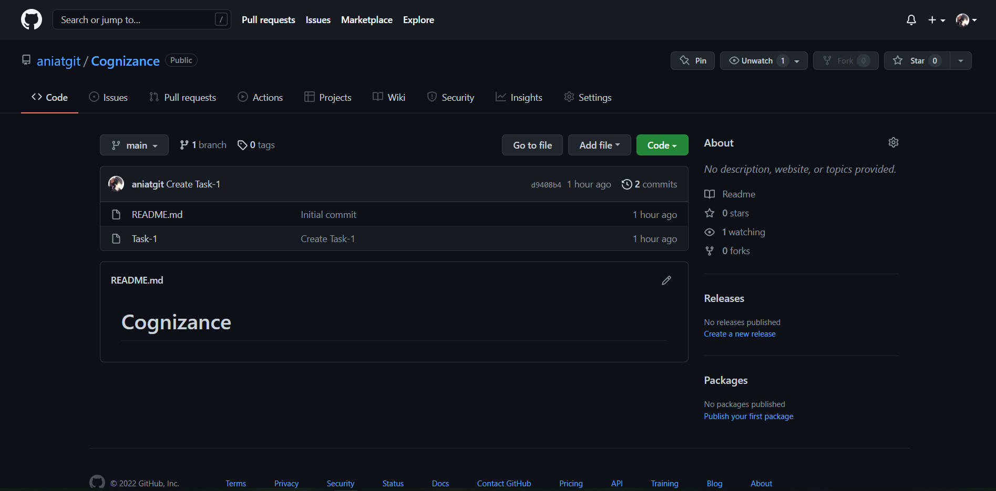

2nd [git config --list --show-origin]( that was a task and I don’t really understand why we do this)

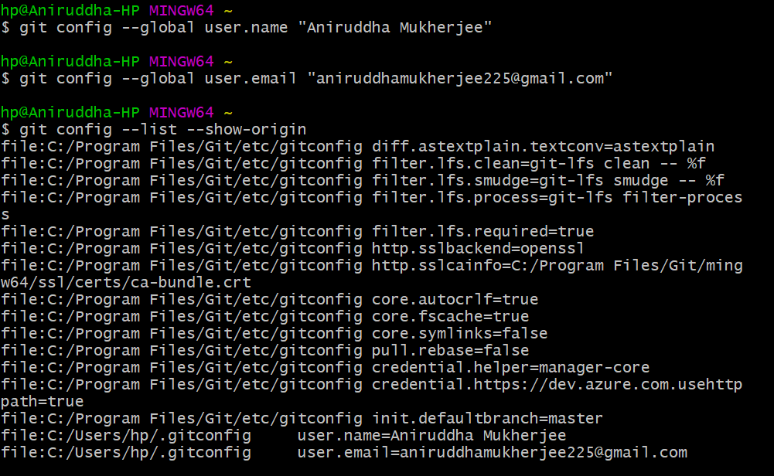

3rd

Bash basic programs

1} clone (it should be done later by order but I made a repository in github first so I had to do it like this)

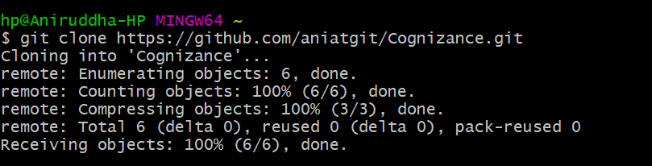

2} add

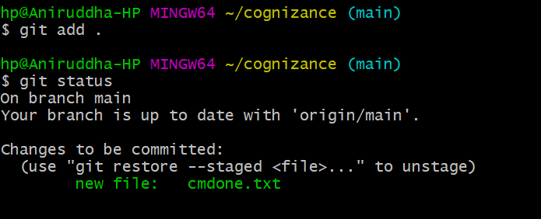

4} checkout

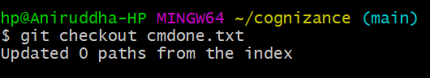

5} checkout -b

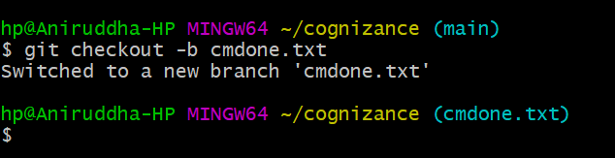

6} fetch --- (I guess because there was no update done to the file so nothing happened)

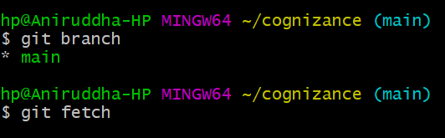

7} merge --- (there was nothing to merge either since I had no updates)

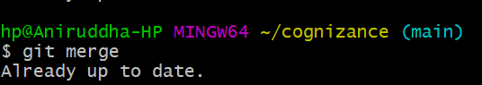

8} pull --- (since there was no update done there was nothing to pull either)

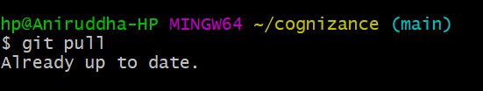

9}reset

